Pre-Visit Lesson: Rocks and Minerals

Goal: To provide the opportunity to observe rock samples and categorize them by observable characteristics.

Objectives:
- To have students describe observable physical characteristics of a selected group of rocks.
- To have the students describe, test, and communicate characteristics of a rock to fellow students.
- To record a set of characteristics students can use to distinguish rock types.
- To perform tests on rocks to determine properties.

Key Concept: Rocks are aggregates of minerals. Rocks have different properties. The properties of rocks reflect the way they were formed, and the minerals in them. Multiple Intelligence approaches: Interpersonal, logical/mathematical, naturalistic.

Content Standard: Earth and space sciences. The student constructs models to compare and explain the components of Earth system – crust, mantle, and core. Explains the process of rock formation.

Materials:
- One to several sets of rocks and minerals.
- Hand lens (6-10)
- Masking tape
- Scissors
- Pencils
- Rock identification books

Procedure:

Rock observation: Prior to the activity, label the rocks in the collection(s)¹ using masking tape² and numbering system, and make a list of rock names by each number. Ask the students to observe the rocks and minerals with a hand lens and record the physical characteristics of each rock and mineral on a data sheet. Break the class into groups of four or more, and provide each group with the same selection of rocks and minerals. Provide each student with a Data Chart (see example below). Have each student fill in the data chart while working together in groups. Allow time for and encourage the students to discuss and ask questions amongst themselves. Students may have questions about the rock’s color, texture, dullness, shininess, pattern, weight, or composition (mineral content/ mineral crystals.) These characteristics should be explained to the students before they begin working in groups. For a summary write down the characteristics and distinguishing features the students came up with on a large piece of chart paper. Include any which may not have been addressed.
B-4

¹ Wards Science Catalogs provide excellent rock specimens. Catalogs can be ordered online
² To permanently mark your rock collection you might consider painting a label strip in white and numbering in permanent ink.
Game: Provide each student or group with a list of rock and mineral names. Still working as a team, have students individually select a rock without showing the rest of the class. The student can hold the rock cupped and concealed in his/her hands.

Students should be challenged to describe its characteristics out loud to the class. Let the class select the described rock from their tray. The rock selected from their tray should have the identical characteristics of the rock described by the student. Keep score, and try to have a prize for the winning team.

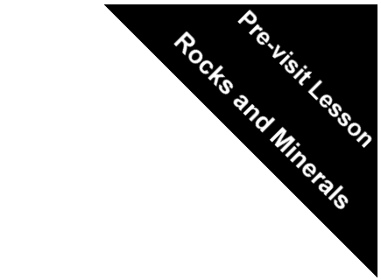
Background information:

Great Falls is mainly comprised of metamorphic rock with sporadic igneous intrusions. Heat and pressure within the Earth changed the original sedimentary rocks of the Great Falls area, forming mica schist, metagraywacke, and amphibolite. Later, igneous intrusions, mainly in the form of dikes, formed igneous lamprophyre and granite. (See the Rock Cycle diagram.)

The solid part of the Earth’s crust is made up of great masses of hard material called rock. A rock can be generally defined as a group of minerals bound together in some way. Rocks are characteristic of the minerals that make up the rock.

Minerals are chemical elements or compounds that are found naturally in the Earth’s crust. Minerals are solid materials having an orderly arrangement of atoms and a definite crystal structure. Most rocks are made up of more than one mineral. Four groups of minerals are: silicate minerals that contain silicon; non-metallic minerals i.e. calcite, sulfur, rock salt, and graphite; metal ore minerals such as gold, silver, copper, lead, tin, zinc, aluminum, and mercury; and gem minerals made up of precious gemstones such as opal, jade, garnet, topaz, diamond, ruby, emerald, sapphire, zircon, and tourmaline.

Rocks are divided into three main groups according to the way in which they were formed. The three kinds of rock are igneous, sedimentary, and metamorphic.


1. Igneous Rocks:
Igneous means formed from fire. The hot molten material generated within the Earth is called magma. Rocks formed from magma that reached the Earth’s surface and then cooled are called extrusive rocks. Magma that reaches the Earth’s surface is called lava. Rocks formed from magma that cooled below the Earth’s surface are called intrusive rocks.
B-5
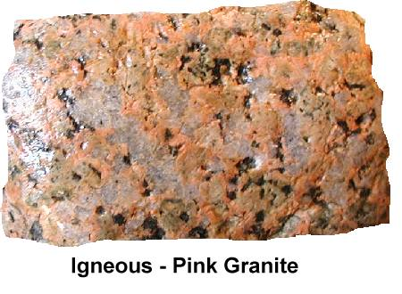
Examples of igneous rock:

Quartz has glasslike crystals that are usually colorless or milky.

Feldspar can be mostly any color, but is usually white.

Mica is usually brown or black, looks shiny, and is layered in sheets.

Granite is used in road construction, buildings, and monuments.
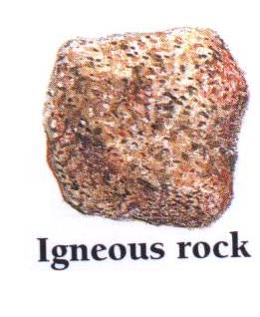

2. Sedimentary Rocks:
Sedimentary rocks are formed from different sediments that are accumulated for thousands of years and then cemented together tightly. The kinds of sediment that form sedimentary rocks are sand, clay, silt, pebbles, gravel, and plants and animals. Steams and rivers carry these sedimentary materials to lakes or oceans where they settle to the bottom. As the sediments accumulate, layers are formed, which slowly change into rock by compaction and cementation by calcium and silica solutions, which bind the fine materials together. Although only about 5 percent of the Earth’s crust is made of sandstone, about 75 percent of the Earth’s land surface is sedimentary rock. Sedimentary rocks are most common at or near the Earth’s surface. Sedimentary rocks cover most of the oceans’ floor. Sedimentary rocks are the only rock type where fossils are found, the remains of plants and animals embedded within sedimentary layers.

B-6
Examples of Sedimentary Rocks:

Sandstone – Can be composed of grains of any type of mineral or rock fragment. However, most sandstones consist primarily of the mineral quartz, or grains of sand that are cemented together. Sandstone may be red, brown, yellow or very light in color; and it can be very soft or hard enough to use as building material. The material that cements the sand particles together determines the hardness and color of the rock.

Mud rocks – Consist of siltstones, mudstones and clay stones. These rocks are made of silt and clay particles -- smaller particle sizes than sand. Many mudstones and clay stones are called shale. Shale normally splits easily into flat, thin pieces. The color of shale varies from gray or green to red, purple and even black.

Conglomerate – Consist of larger pebbles and gravel particles cemented together. Other finer particles may be found in the spaces in between larger particles. Conglomerates tend to form along riverbanks, where deposition of larger materials occurs.

Limestone -- This kind of sedimentary rock includes plant and animals that live in the ocean and take up calcium carbonate from the water to form shells and skeletons. These shells accumulate on the sea floor and harden to become great beds of calcium carbonate, or limestone.

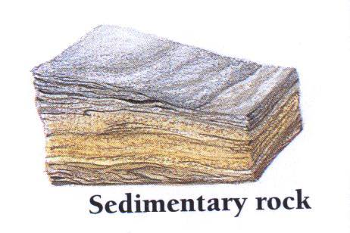
Coal: is a sedimentary rock formed from the remains of plants and animals that died long ago and accumulated in a sinking swamp.

3. Metamorphic Rock:

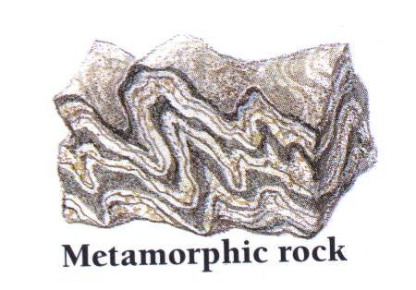
Metamorphic rocks are formed from sedimentary and igneous rocks that are buried deep in the Earth’s crust and changed by heat pressure, and fluid activity. Metamorphic means change in form. Some changes are physical in nature where the original mineral composition is rearranged. Other changes are chemical where new materials are formed. When rock is buried deeply it is subjected to tremendous pressure, allowing the mineral grains to become more closely packed under the
B-7
tremendous weight. Recrystalization occurs, where rocks form smaller and denser minerals. Heat increases the rate of chemical reactions that may produce new mineral patterns (assemblages), which are different from the original rock. Heat can occur adjacent to magma bodies deep in the Earth, or along boundary lines of moving plates (plate tectonics). Water contained deep in the Earth’s crust can move through cracks and pore spaces in rock as hot solutions. Water carries different mineral materials (ions) in solution, which increase the chemical reaction in metamorphism of subterranean rocks.

Examples of Metamorphic Rocks:

Schist – Most schist is formed from clay-rich sedimentary rocks. Mica schist contains high mica mineral content. Schist typically forms in regional metamorphism, where a large are is subjected to folding from the movement of the earth commonly along plate boundaries. Wavy patterns are common in schist.
Gneiss – is a metamorphic rock that is streaked or banded and is commonly formed from igneous granite. Gneiss is mostly composed of quartz, feldspar, and dark hornblende
Marble – is formed from sedimentary limestone. It is a large crystal rock.
Slate – is formed from sedimentary shale. It is a fine grain rock that splits easily into thin sheets.
Quartzite – is formed from quartz sedimentary sandstone, and is a very hard rock. It is usually white, but impurities cause reddish or other colors.
Hard Coal – is formed from soft coal. It has more carbon than soft coal. Hard coal is also changed by further heat and pressure to form graphite, which is pure carbon. It is no longer useful as a fuel so it is used in pencils.
ROCKS AND MINERALS

DATA CHART

Number / Rock/Mineral | Color | Distinguishing Features

ROCKS AND MINERALS

Interpret your results,

1. Do you have any groups containing one rock? If so, how many?
___________________________________________________________________________________________________________________________________________________________________________________________________________________________________________________________________________________

2. Which properties did you use to classify the rocks?
__________________________________________________________________________________________________________________________________________________________________________________________________________________________________________________________________________________________________________________________________________________________________________________________________________________________________________________________________________________________________________________________________________________________________________________________

